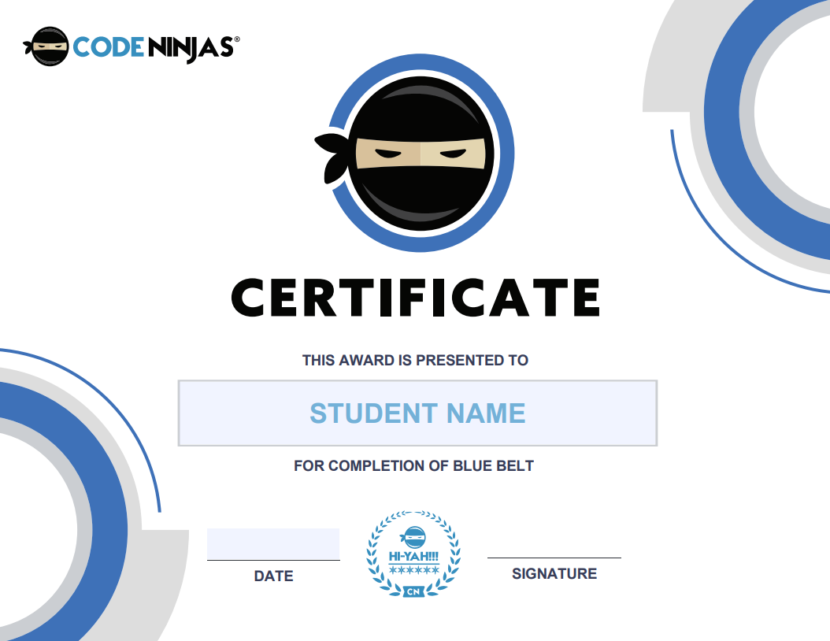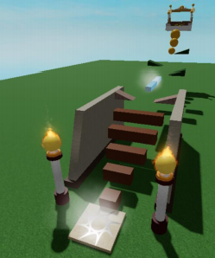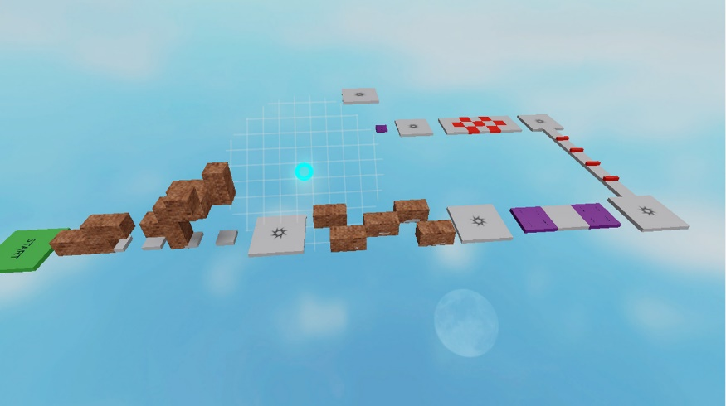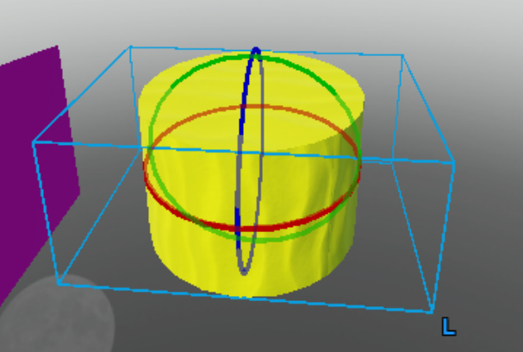

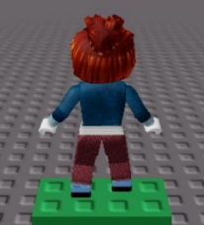



Hello Dan

CHILDNAME+” jumped right back into the Create Studio today creating “+hisher+ own obstacle course!

Creating our own detailed obstacle course ‘Obby’ is a brilliant task that introduces “+CHILDNAME+” into more of the 3D design concepts and grows +hisher+ confidence in using the Create Studio’s software. Breaking out the new tools “+heshe+” learned about part manipulation, “+CHILDNAME+” got to work by incorporating 3D objects into an awesome and creative formation!

Before the fun could fully begin, “+heshe+” had to remove our worlds baseplate (the floor) so our obstacle course would be ‘floating’ and we would off if the player missed a step! Then we learned how to add the most important block of all, the ‘SpawnLocation’! This would set where all of our courses would begin, and where would respawn should we fall off!

Building from last lesson where “+CHILDNAME+” had a look into anchoring objects, it was much more important here! If we did not ‘anchor’ our objects in space they would just fall forever as we have already deleted the floor of our game.Last lesson we also got introduced into how to change the positions & size of our objects, but here we got to change the ‘orientation’ of each object, allowing for much more complex shapes to be used! Brilliant work “+CHILDNAME

~sensei chris

